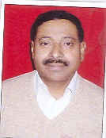

**Prof. s.r.vishwakarma**

**Teaching and Research Experience:**

17 years of Teaching and 23 years of Research Experience.

**Research Interest**

* Solid State Physics
* Solid State Devices
* Microwave Electronics
* Laser and Optical Fibre

**Work Experience**

* **Professor** in Physics & Electronics Department, Dr. Rammanohar Lohia Avadh University, Ayodhya from 23/11/2010 till now.
* **Associate Professor** in Physics & Electronics Department ( 26/05/2007 – 25/05/2010).
* **Reader** in Physics & Electronics Department( 26/05/2004 – 25/05/2007).

**No. of research papers in journals: 33**

**No. of research papers in Conference: 23**

No. of Ph.D Edited/Produced: 04